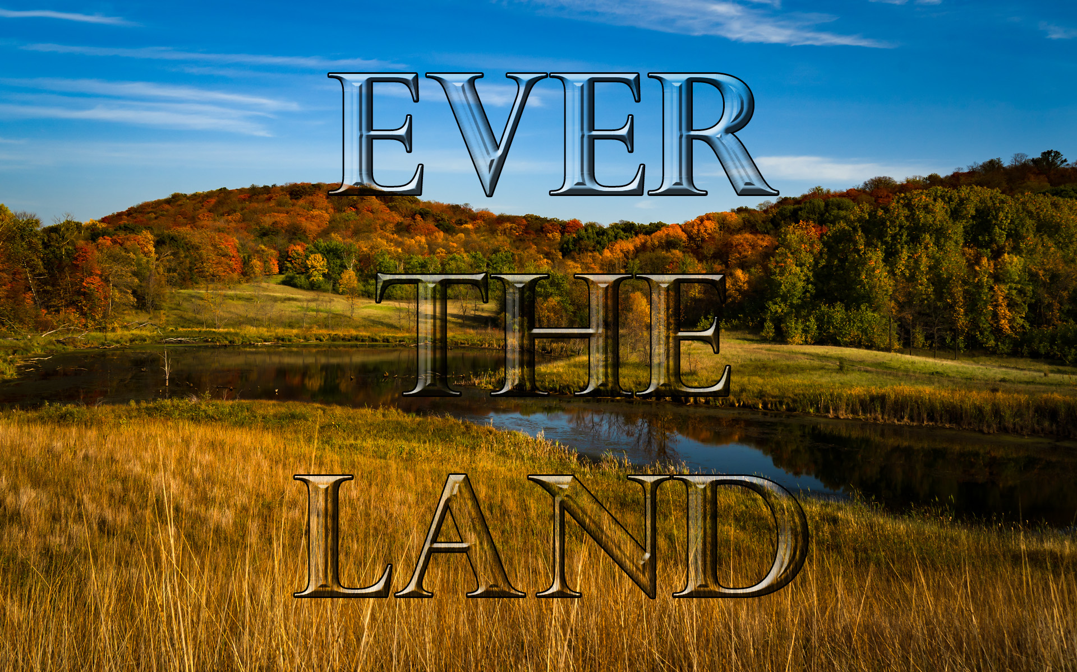**7+ Lag Stevne Registration**

**Ever The Land**

**North Dakota State College of Science Campus Wahpeton, N.D.**

**July 11 – 13, 2024**

**Name(s) for badges ____________________________________________________**

**Address______________________________________________________________**

**City______________________________State_______________Zip_____________**

**Email______________________________________Phone_____________________**

**Description How many Item cost Total**

**Registration __________ $30 __________**

**(covers entertainment, classes & genealogy.)**

**Bus Tour __________ $50 __________**

**Thursday Breakfast __________ $10.50 __________**

**Thursday Noon __________ $10.50 __________**

**Thursday Eve __________ $10.50 __________**

**Friday Breakfast __________ $10.50 __________**

**Friday Noon __________ $10.50 __________**

**Friday Eve __________ $10.50 __________**

**Saturday Breakfast __________ $10.50 __________**

**Saturday Noon Box Lunch __________ $10.50 __________**

**(Only if your lag is eating on campus)**

**_______________________________________________________________________**

**Total: __________**

**Mail this form by June 30th with check made out to __Sigdalslag__________**

**and send to:**

**Linda Mohn**

**14782 Erickson Circle**

**Detroit Lakes, MN 56501**

**\*\*\*\*\*\*\*\*\*\*\*\*\*\*\*\*\*\*\*\*\*\*\*\*\*\*\*\*\*\*\*\*\*\*\*\*\*\*\*\*\*\*\*\*\*\*\*\*\*\*\*\*\*\*\*\*\*\*\*\*\*\*\*\*\*\*\***

**\*\*\*Note: Dorm reservations are sent separately to Chet Habberstad**