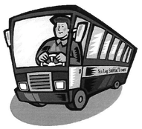
Thursday, July 11th, 2024 09:30 am

Pre-Registration required. Tour cost of $50 includes lunch.
Tour will include stops at - Prairie Wetlands Center in Fergus Falls
- Fort Juelson in rural Underwood
- Prospect Civil War Museum in Battle Lake (Lunch)
- Historic Phelps Mill in rural Underwood

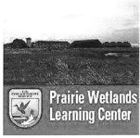
Prairie Wetlands Learning Center

The interpretive center presents the “prairies” the way the settlers found them when they settled here. The interpretive center offers enough to keep your interest, but there is also a short ½ mile walk around a wildlife area if you're up for it. The center includes hundreds of acres of natural prairie one could enjoy if you had all day.

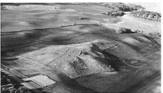
Fort Juelson

This earthen fort was built was built in July of 1876 in response to rumors that the Indians had already killed settlers in Foxhome, French and Fergus Falls. It was built under the leadership of Civil War veterans Hans Juelson and Berge O. Lee by settlers in Tordenskjold township. The 120 x 100 foot structure had 4'-4 ½' thick walls and could house food and ammunition in case of an Indian attack.

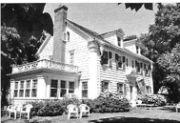
Prospect House – Civil War Museum

This Georgian mansion was built in 1882. In 1886, owner Cap Colehour added on and created the area's first and largest resort, “The Prospect Inn” which operated for 38 years. The lower level features a Civil War museum. Stairs are involved.

Tour participants will have lunch at the Shoreline Restaurant in Battle Lake in two shifts. Half of the group will visit the house and museum first and then have lunch; the other half will eat first and then tour Prospect House.
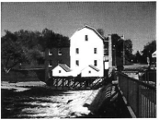
Phelps Mill

William E. Thomas opened Phelps Mill in 1889. The mill closed in 1939. All of the original machinery is still in place, as if it was closed yesterday. It was added to the National Register of Historic Places in 1975.

